How to Upload a Watch List via Batch

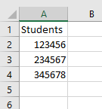
Often, you have queries from other systems that would be useful to your work within the Pathways system. Rather than recreate that list within Advanced Search or manually add students to a Watch List, you can load students into the system from the list you already have using the Batch feature.

- Before you start in Pathways, you will need to create a .csv file in Excel. The spreadsheet should be simply a header and a list of PeopleSoft IDs of the students that you want to include in your Watch List.

- Click on the List & Searches icon.

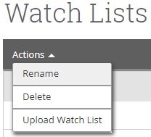

- Click the Actions drop down and select Upload Watch List.

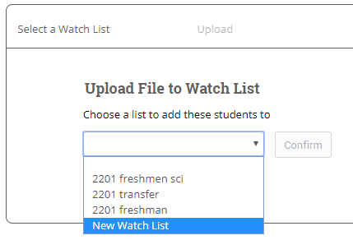
- To choose a list, click on the little triangle and select the list or create a new one then click Confirm.

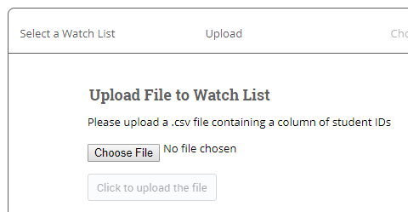
- Click on the Choose File button to select the file you want to load and click on the Click to upload the file button.

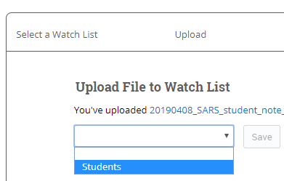
- Select the header of the column that holds all of your PeopleSoft ID’s and click the blue Save button.

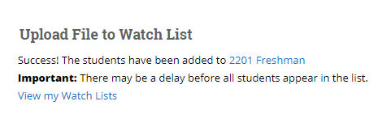
- Depending on the size of the Watch List, it may take a few minutes to load all of the students into the Watch List.

